**Impact of Female Mating Status on Male Courtship Behaviour in the Sexually Cannibalistic New Zealand Fishing Spider *Dolomedes minor* (Araneae, Pisauridae)**

**INTRODUCTION** - Courtship is a key way in which animals, especially males, increase their reproductive success (Andersson & Iwasa, 1994). It covers a wide range of sensory modalities used by males to facilitate and engage in reproduction with females (Bastock, 1967). For instance, salamanders exhibit visual ornament patterns (Ancillotto *et al*., 2022), eared moths engage in ultrasonic communication (Nakano *et al.*, 2015), songbirds perform duet dancing (Soma *et al.*, 2019), and cockroaches use chemical and gustatory senses during mating (Wada-Katsumata *et al*., 2023).

Besides being selected for their role in enhancing reproductive success (Andersson & Iwasa, 1994), courtship behaviours also entail energetic and survival costs. These costs have been demonstrated through increased physiological expenses, such as lactate production in crickets (Mowles, 2014), and survival costs associated with predation risk in firefly light signals (Woods *et al.*, 2007). Consequently, when the costs associated with courtship outweigh the benefits, it is expected that males make careful decisions to adjust their reproductive effort based on the reproductive value of the female (Servedio & Lande, 2006). In such cases, mating with an already mated female leads to a decrease in fitness due to sperm competition with other males and a reduced likelihood of paternity (Parker, 1970; Thomas & Simmons, 2007). This phenomenon has been widely documented in bee species, where males are more attracted to and detect virgin females through chemical cues (Ayasse *et al*, 1999; Kukuk, 1985), as well as in chameleons, where courtship behaviours differ based on female reproductive condition (Kelso & Verrell, 2002).

In this context, the study of spider taxa is particularly relevant for understanding reproductive behaviours and mating mechanisms due to their wide range of communication signals and courtship behaviours employing various sensory modalities (Robinson, 1982). For example, peacock spiders utilise elaborate dances, bright colours, and vibrations (Girard *et al.*, 2015), wolf spiders engage in vibrational communication (Chiarle *et al*., 2013), and gift-giving spiders present nuptial food gifts (Prokop & Okrouhlík, 2021). Furthermore, courtship in male spiders is particularly costly and risky as females are typically aggressive, and many species exhibit sexual cannibalism (Robinson, 1982). Female aggression introduces a constraint on male mating choice, limiting the number of matings they can engage in, sometimes even to a single mating in species with obligatory mate consumption (Elgar, 1992; Knoflach & Van Harten, 2010). Consequently, male spiders are expected to face significant limitations on their reproductive opportunities, highlighting the importance of carefully selecting the best female based on her quality.

Male choosiness has been widely investigated in spider groups where sexual cannibalism occurs, showing that males generally prefer to mate with unmated females to reduce sperm competition and avoid increased aggressiveness in already mated females (Gaskett, 2004; Herberstein *et al.*, 2002; Schneider *et al.,* 2015). Some studies have also shown that courtship traits are costly and adjusted according to female mating status (Cargnelutti *et al.,* 2021; Solano-Brenes *et al*., 2021). The ability of males to assess the female mating status and adapt their behaviour is primarily associated with chemical cues released by the female into the air or through contact with her silk (Cayet & Schneider, 2020; Copperi *et al.*, 2019; Thomas, 2010; Xiao *et al*., 2015). However, the mechanisms underlying male decision-making behaviour are still highly complex and vary across spider species and populations, as males also integrate other factors such as costs related to female availability or their own condition (Schneider *et al.*, 2015; Tuni & Berger-Tal, 2012).

Nursery web spiders (Pisauridae) constitute a diverse group, with several species serving as model organisms for studying courtship behaviours. One nursery web genus, *Dolomedes spp.* comprises approximately 100 species, which have been extensively studied in the context of mating system evolution, extreme male mating behaviours, and sexual cannibalism (Arnqvist, 1992; Eberhard *et al.*, 2020; Fisher & Price, 2019; Schwartz *et al*., 2014; Stålhandske, 2001). For instance, cannibalism has been widely investigated in *D. triton*, where it constitutes approximately 5% of the observed diet of the species (Johnson, 2001; Johnson & Sih, 2005; Zimmermann & Spence, 1989). Additionally, studies have explored the significance of vibrational signals on their predation (Bleckmann & Lotz, 1987) and courtship behaviours (Arnqvist, 1992).

*Dolomedes minor* is endemic to New Zealand, where it primarily inhabits near-water vegetation habitats and is mainly active from November to May during the austral summer (Vink & Dupérré, 2010). Little is known regarding the courtship behaviour of *D. minor* and the occurrence of sexual cannibalism. Here, we investigate whether male *D. minor* adjust their courtship behaviour based on female mating status. We predict that when encountering an already mated female, males will exhibit shorter courtship and mounting behaviours, as well as distinct courtship structures to allocate less energy in comparison with males courting unmated females. To achieve these objectives, we conducted laboratory-based mating experiments using both unmated and already mated *D. minor* females. We first describe the fine-scale behaviour of male *D. minor* and then employ sequential analysis and comparisons of courtship duration to assess differences in courtship investment and structure between the two experimental female groups.

**MATERIAL AND METHODS**

**Spider Collection and Maintenance**

All *D. minor* individuals (N = 393) were collected from various near-water habitats on the campus of the University of Waikato (Hamilton, New Zealand). The collection took place between September 2020 and April 2021, corresponding to the summer season and the spiders’ primary activity period. Fieldwork was conducted exclusively at night, as individuals were more active and easily located using a head torch due to the reflection of their eyes. Collected individuals were brought to the Invertebrate Behavioural Ecology Lab (University of Waikato, Hamilton, New Zealand), where their developmental stage was assessed through anatomy of their genital pieces. Only juvenile and penultimate (*i.e.* one moult from maturity) males and females were selected for mating experiments to ensure that all individuals had not mated before collection. Spiders were individually reared to maturity in plastic containers (150 mm x 95 mm x 60 mm) with a wet cotton pad and a piece of egg carton as an enrichment device. Individuals were fed live crickets twice a week, and containers were cleaned weekly to prevent mould growth and waste accumulation.

**Mating Assays**

Laboratory mating experiments between mature individuals were conducted from March to August 2021. Trials were performed in plastic containers (265 mm x 235 mm x 125 mm) with a mesh roof and wall on one side to serve as climbing support. Females were fed the day before the experiments to control for hunger-related aggressiveness and were introduced into the mating arena first, followed by the males 10 minutes later to allow the female to acclimate. Each female participated in one mating experiment until copulation and then in a second assay with a new set of unmated males, enabling comparison of male courtship behaviour between mated and unmated females. Mating trials were recorded for a duration of 4 hours after the introduction of the male. To analyse and compare male courtship behaviour when paired with mated versus unmated females, we analysed videos from 30 mating trials (N = 15 unmated females, N = 15 mated females) where courtship occurred at least once. In the ‘mated’ group, two males were reused in different trials, but with different females, due to limitations in spider availability.

**Description of Courtship Behaviour**

For each mating trial, we initially scored the videos using BORIS software to quantify the number of female attacks towards males and describe the timing of male courtship. We then scored different parameters of courtship investment as 1) courtship duration, from the first male cue to the end of mounting, 2) mounting duration, from the start to end of mounting, and 3) latency to mount, from the male introduction to the beginning of mounting. We then rescored each video to describe the fine-scale courtship elements of *D. minor* male courtship. Videos were randomly and blindly sampled between the two groups to prevent observer bias, and a single observer performed all scoring. All trials were initially screened to compile an ethogram comprising all relevant courtship elements (Table 1). Due to the large amount of time required to code fine-scale behaviour during long mating assays, we decided to limit our analysis of courtship structure to one bout of courtship for each trial. We chose the first courtship sequence from each trial that resulted in mounting behaviour (see below for definition), which was observed at 0.5x speed to score all observed courtship elements. Our justification for choosing the first courtship sequence, rather than the sequence that may end in copulation was that 1) not all trials ended in copulation for the mated female group, and 2) using the first courtship sequence allowed us to standardise the opportunity each male had to gain information when contacting the female during a trial. Courtship elements were considered non-exclusive as they could be performed simultaneously and were grouped into categories based on the body part used by the male.

**Statistical analyses**

All statistical analyses were performed with R software and figures were made using the package ‘ggplot2’. To analyse the impact of female mating status on the timing of male courtship behaviour, we used non-parametric Wilcoxon signed-rank tests for paired values on the measured courtship duration, mounting duration and latency to mount, between the two groups. The same analysis was performed to assess the impact of female mating status on her number of attacks. To compare the impact of female mating status on the fine-scale courtship behaviours, we used the ‘igraph’ network R package to produce networks of transitions between elements for each group. With the behavioural sequences exported from BORIS software, we grouped all behaviours that were recorded simultaneously, as new combined behaviours. For example, when courtship behaviours were performed with legs and pedipalps at the same time, they were combined as a ‘Leg & Pedipalp Display’ behaviour. We removed all behaviours that had a duration of less than one second as we considered them to be artefacts linked to the inaccuracy of our observations and scoring. Then, we compiled the behavioural sequences previously scored and used the ‘igraph’ network analysis R package to compute for each group an observed matrix of behavioural transition frequency, where each cell corresponded to the number of occurring transitions from the behaviour in row to the behaviour in column. For each group, we then repeatedly and randomly permuted all behaviours within the behavioural sequences until obtaining 10,000 new matrixes of randomly generated behavioural transitions. These matrixes gave each transition of each group their expected distribution if behaviours were randomly distributed along behavioural sequences. We extracted the 95% quantile of each distribution and compared it with the first observed matrix of transitions. Observed behavioural transitions that had a frequency higher than the calculated 95% quantile were considered to occur more often than randomly and be significantly contributing to the overall structure of courtship behaviour. After keeping only significant behavioural transitions, we plotted the behavioural structure of courtship as networks for each of the groups to compare for structural differences (Bakeman *et al*., 1996; Green & Patek, 2018). Between the two groups, we compared the frequency of each behaviour and behavioural transition with Wilcoxon mean comparison tests for paired values.

**RESULTS**

**Description of Male Courtship Behaviour**

During the mating trials, males swiftly detected the presence of the female upon introduction and initiated courtship behaviour. In contrast, the females mainly remained motionless and positioned themselves on the mesh roof or wall of the container. The males gradually approached the females during the trials, using a combination of vibrational and visual signals, until they were in close proximity to the female. This approach involved a start-and-stop behaviour, with males continuing to emit signals when near the female until suddenly mounting her. Once mounted, the males continued the start-and-stop behaviour, accompanied by sort sequences of leg and pedipalp movements aimed at repositioning. This allowed the males to bring their pedipalps closer to the female’s genitalia, with their bodies consistently positioned perpendicular to the female (Figure 1). When in close proximity, the male attempted copulation. Mounting was often repeated multiple times before successful copulation, with males occasionally retreating and starting the process again (mean = 5.87, se = 1.14 in the unmated group). In four trials out of 15 involving unmated females, sexual cannibalism occurred, but we were unable to analyse these events due to limitations in our experimental setup.

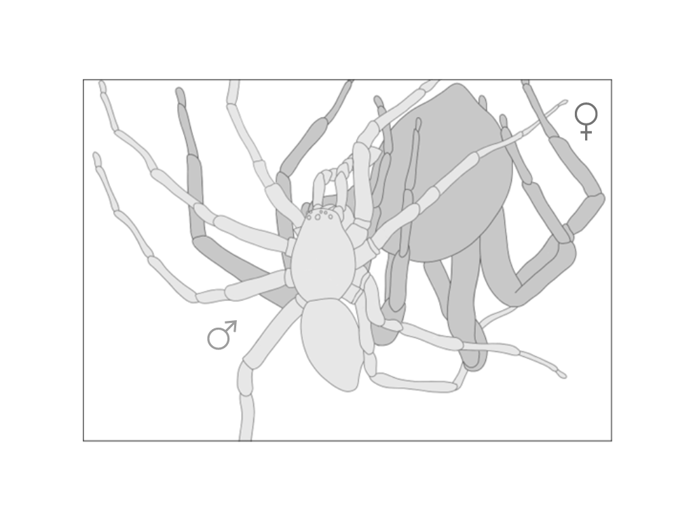

**Figure 1.** Schematic drawing of the reproductive position in *Dolomedes minor*, based on near pedipalp insertion events observed in the mating trials analysed. Male is coloured in light grey and female in dark grey.

During courtship, *D. minor* males exhibited specific behaviours and patterns with their body parts. Scoring of fine-scale courtship elements has led to the description of 14 distinct elements including leg, pedipalp and abdominal motions performed in the air or by contacting the substrate. Motions performed with legs had an important diversity, with a total of 6 different elements described (Table 1). These leg motions were often exhibited simultaneously and independently between each leg and were sometimes performed by grabbing the female silk dragline with the tarsus. However, they were often not clearly defined and chaotically mixed, which make it difficult to always clearly and consistently distinguish them during courtship display.

**Table 1.** Ethogram of male courtship behaviours in *Dolomedes minor*.

|  |  |  |  |
| --- | --- | --- | --- |
|  |  | **Behaviour** | **Description** |
|  |  |  |  |
| Leg Display |  | Leg Raise | Raising of one or more of the legs, straight or slightly bent, at an angle between 50 and 90°, for at least one second without performing any specific aerial pattern with the tarsus or the rest of the leg. Behaviour ends when the leg is lowered and touches the substrate or a specific vibrational pattern is drawn with the tarsus or the whole leg (See Wave and Aerial Tremulation). |
|  | Wave | Raising of one or more of the legs, straight or slightly bent, a performing several circular or vertical fluid aerial movements with the whole leg and tarsus. Vertical movements can be performed between on a 90° angle. Behaviour ends when the leg has stopped moving for more than one second (see Leg Raise) or is lowered to touch the substrate. |
|  | Aerial Tremulation | Raising of one more of the front legs, slightly bent, performing quick and repeated vertical movements with the whole leg, freely in the air or by grabbing a female silk dragline with the tarsus in some cases. Behaviour ends when the leg has stopped moving for more than one second (see Leg Raise) or is lowered to touch the substrate. |
|  | Wipe | Following Leg Raise, Wave or Aerial Tremulation behaviours, instead of simply touching the substrate, the individual is lowering its leg straight on the site of its body and is wiping the substrate with its tarsus, always towards its cephalothorax. It is often followed by Quick Tapping. |
|  | Quick Tapping | Extension forward of one or more of the front legs with a quick tapping of the tarsus on the substrate or the female silk dragline. Sometimes performed on female legs when the male is close to a mounting attempt. |
|  | Leg Rubbing | While mounting the female, legs are bent and perform quick vertical and horizontal repeated movements. Often associated with a repositioning of the male on the female and approaching of the pedipalps towards the female genitalia. It is the only leg behaviour performed during mounting. |
|  |  | Pedipalp Display | Quick vertical and repeated movement of both pedipalps in the air, sometimes while grabbing a female silk dragline. |
|  |  | Body Surge | Sudden tap of the abdomen on the substrate with contraction of the whole body. Often paired with an abrupt tap of some of the legs on the substrate, especially when they are already raised. |
|  |  | Abdominal Tremulation | Repeated quick horizontal vibration of the abdomen performed without touching the substrate. Abdomen is mainly remaining aligned with the rest of the body. |
|  |  | Grooming | Brushing of the pedipalps, legs and chelicerae together, sometimes only two of them. |
|  |  | Approach | Locomotion towards the female accompanied by clear courtship signals. |
|  |  | Retreat | Quick moving away from the female in response to a clear signal from her such as a vibration, a movement or an attack. Behaviour can be triggered when the male is mounting the female, always leading to the end of Mount behaviour. |
|  |  | Mount | Male climbs onto the female’s abdomen. |
|  |  | Pedipalp Insertion | Extension of one pedipalp toward the genitalia of the female which leads to embolus insertion and successful copulation. |

**Influence of Female Mating Status on Female Aggressiveness**

There were no significant differences in the number of attacks (W = 149, P = 0.1301) emitted by females towards males between groups with unmated and mated females (Figure 2).

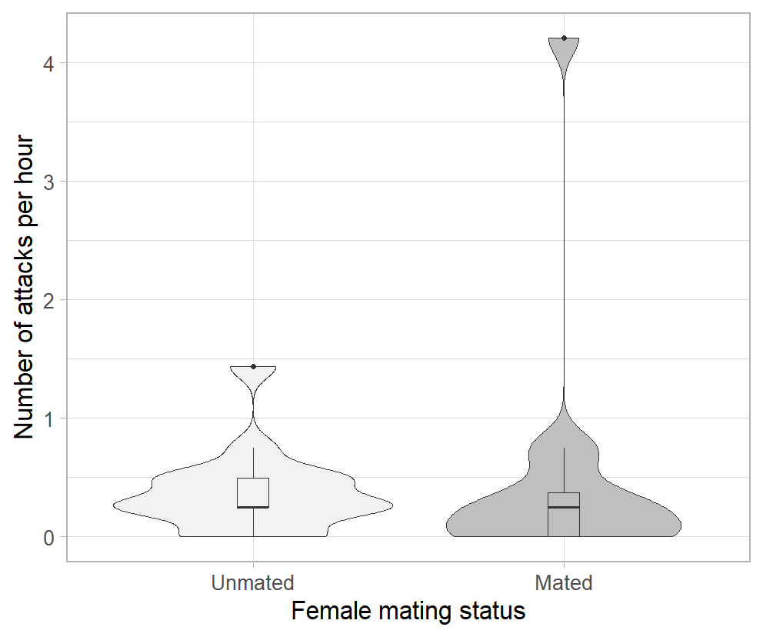

**Figure 2.** Comparison of the number of female attacks towards male per hour between trials with unmated (N = 15) and already mated females (N = 15). Plots represent the density distribution of the variable as well as the median and the interquartile and 1.5x interquartile range. There were no significant differences between the two groups on Wilcoxon signed-rank test for paired values.

**Influence of Female Mating Status on Male Courtship Investment**

There were no significant differences in the courtship duration (V = 22, P = 0.625) and the mounting duration (V = 34, P = 0.557) between groups with unmated and mated females. However, the latency to mount was significantly longer in group with mated females (unmated: mean = 4410.5, se = 561.2; mated: mean = 6687.2, se = 1150.0; V = 3, P = 0.01) (Figure 3).

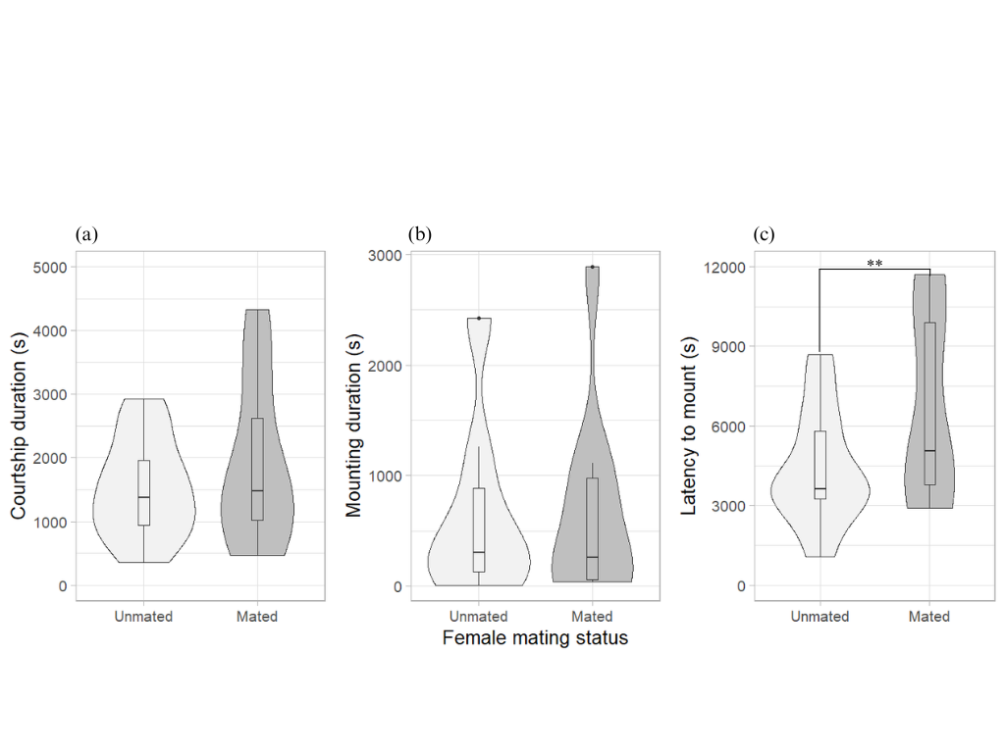

**Figure 3.** Comparison of male first reproductive attempt parameters in *Dolomedes minor* between trials with unmated and already mated female, with (a) duration of first courtship segment leading to mounting behaviour, (b) duration of first mounting behaviour (included in a) and (c) latency to mount the female. Plots represent the density distribution of the variable as well as the median and the interquartile and 1.5x interquartile range. There were only significant differences for the latency to mount, which was higher in the group with mated females on Wilcoxon signed-rank test for paired values.

**Influence of Female Mating Status on Male Courtship Structure**

A total of 15 mating trials with unmated females and 10 mating trials with already mated females were scored for the analysis of courtship structure. In both groups, a total of 14 behaviours and 32 significant transitions were mapped (Figure 4). For accuracy, all leg motions were grouped as ‘Leg Display’ (Table 1) and the ‘Abdominal Tremulation’ behaviour wasn’t included in the scoring, as male’s position often made it impossible to observe. Male courtship sequences in both groups were mainly structured around two phases. During Phase One, *D. minor* males would first approach the female, while alternating between ‘Freezing’ and visual signals. In both groups, ‘Freezing’ and ‘Leg Display’ were the most frequent behaviours in this phase and were frequently transitioning between each other. Grooming behaviours were sometimes performed during this phase, but not in Phase Two. Eventually, the male approach led to Phase Two, starting with a mounting attempt. During Phase Two, ‘Freezing’ and ‘Leg & Pedipalp Display’ were the most frequent behaviour in both groups and once again were frequently transitioning between each other. Phase two finally resulted in either successful copulation or a retreat behaviour, often in response to a female signal. In both groups, ‘Retreat’ behaviour occurred in both phases and always led to ‘Freezing’ and the start of a new Phase one approach. Finally, there were no significant differences between any of the behaviour frequencies and behavioural transition probabilities between the two female groups, except for the ‘Leg Display’ behaviour when mounted, which was more frequent in mating trials with unmated females (V = 33, P = 0.04) (Figure 3).

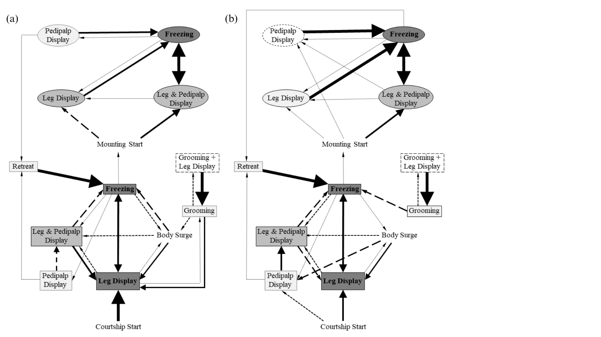

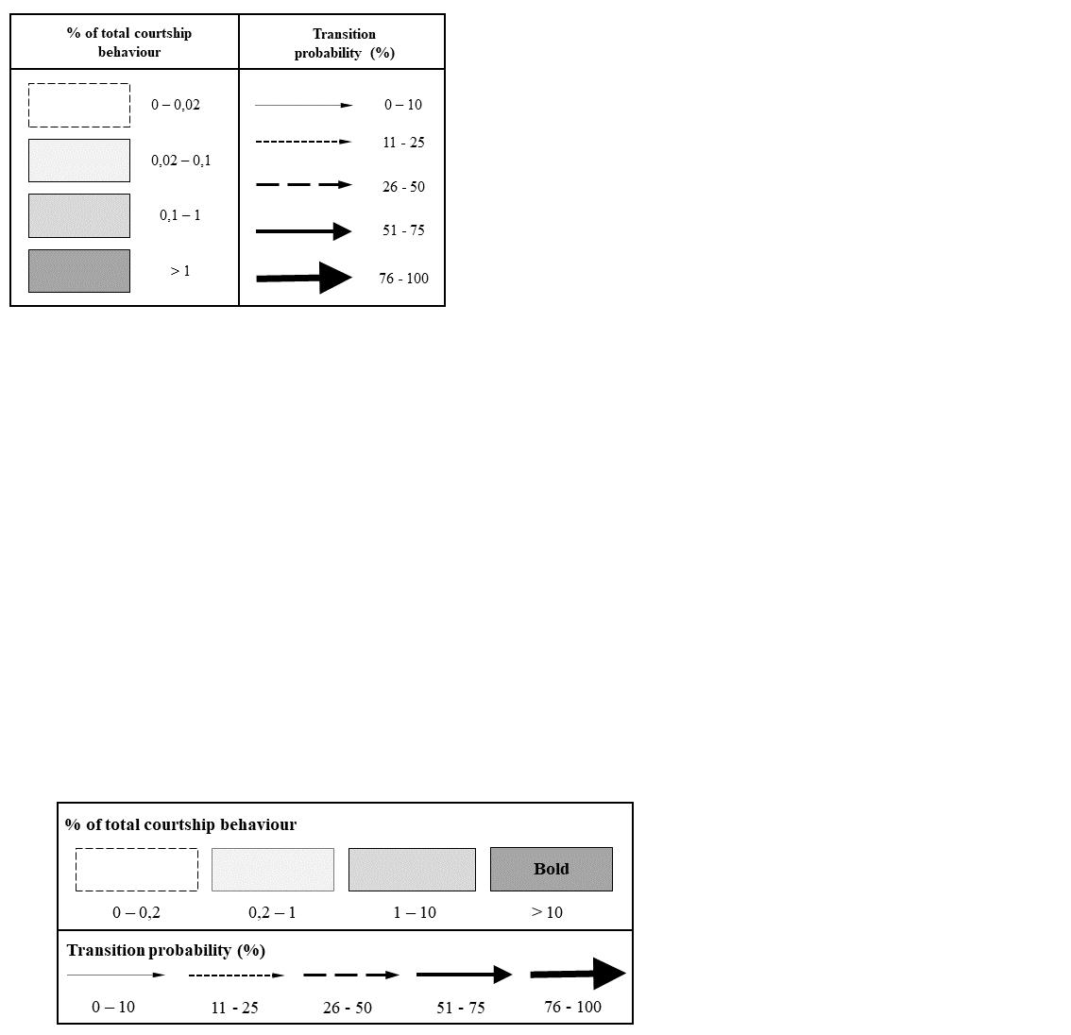

**Figure 4.** Sequential analysis of *Dolomedes minor* male courtship behaviour exhibited during mating with (a) unmated females (n = 15) and (b) already mated females (n = 10). Only behavioural transitions that were significant of the courtship structure were represented. Rectangles represent behaviours exhibited by males during last approach attempt before mounting (Phase One), whereas circles represent behaviours exhibited during their first mounting on the female (Phase Two).

**DISCUSSION**

We observed that male *D. minor* displayed ritualised courtship behaviour when encountering a female, which included various visual communication signals and a diverse range of leg movements during the approach and mounting process. The aggressiveness of *D. minor* females towards males was not directly influenced by their mating status, indicating that male behaviour might not be a direct response to female attacks. Surprisingly, courtship and mounting durations were not found to be dependent on female mating status, however, there was a higher latency to mount in males encountering an already mated females. Overall, we therefore found limited evidence that males adjust their courtship behaviour based on assessment of female mating status, suggesting that constraints related to sperm competition may not be the dominant factor influencing male courtship decision.

**Male Ritualised Courtship and Communication Signals**

In our observations, male *D. minor* exhibited a wide range of courtship behaviours, including various mechanical communication signals such as leg and pedipalp waving, as well as tapping on the substrate. These behaviours were consistently observed during the male’s approach and the mounting process. The presence of vibrational and visual signals in courtship behaviour is a common characteristic among lycosid and pisaurid spiders (Eberhard *et al*., 2020; Gibson & Uetz, 2008; Hebets, 2005; Hebets & Uetz, 1999; Hoefler *et al*., 2008). Previous studies on several *Dolomedes* species, such as *D. triton*, *D. fimbriatus*, and *D. scribens*, have already documented the occurrence of vibrational and visual signals during courtship, including abdominal vibration, leg movements, and following the female’s silk draglines (Arnqvist, 1992; Kaston, 1936; Roland & Rovner, 1893). These previous findings align with the courtship behaviour of *D. minor* presented in our study.

The role of vibrational communication signals emitted by male spiders during courtship has been extensively investigated, particularly in web-building spiders where vibrations are transmitted through the female’s web (Vibert *et al.*, 2016). Numerous studies have focused on describing these signals and their effects, including stimulating receptive females to mate, which may vary depending on female mating status, as well as reducing the risk of cannibalism (Maklakov *et al*., 2003; Sivalinghem & Mason, 2020; Wignall & Herberstein, 2013). Although lycosid and pisaurid spiders do not build webs for prey capture, females produce silk draglines that have been observed to be followed by lycosid males emitting vibrational communication signals (Gibson & Uetz, 2008; Tietjen & Rovner, 1980). Similar silk-following behaviours have been described in pisaurid spiders, and the importance of vibrational sensitivity has been demonstrated in their reproductive behavior, enabling females to distinguish conspecific males from prey (Arnqvist, 1992; Barth, 1985; Bleckmann & Barth, 1984; Bleckmann & Bender, 1987). These studies support the idea that male spiders may make investment decisions in their vibrational communication behaviour to minimize their risk of cannibalism and enhance female acceptance.

Such behaviours, which heavily rely on motor performance, likely impose an energetic cost on the male throughout the entire courtship (Clark, 2012). Similar courtship costs have been documented in various animal species, including spiders, and are known to depend on the male's condition and energy allocation ability (Byers et al., 2010; Hoefler et al., 2008). Additionally, females exhibited sexual cannibalism behaviour towards males. These findings confirm that male *D. minor* spiders engage in a ritualized pre-copulatory courtship behaviour with behavioural requirements that may result in an evolutionary compromise. During their courtship, males may experience an energetic cost associated with female acceptance while simultaneously trying to evade sexual cannibalism.

**Adaptative Courtship Behaviour Depending on Female Mating Status**

Female mating status has previously been shown to be important for male mate choice, including courtship behaviour, in several spider species. For instance, in funnel web spiders (Atracidae), males have been demonstrated to prefer unmated females and exhibit different courtship behaviours (Riechert & Singer, 1995). Similarly, lycosid spiders have been found to employ different mating strategies depending on the female mating status, with shorter mounting latency when the female was already mated (Bunch & Wilgers, 2011). However, contrary to our prediction, we found little evidence that *D. minor* males adjust their courtship investment in response to female mating status. Our study demonstrated that the duration of courtship and mounting in *D. minor* was not influenced by the female mating status. Furthermore, apart from a reduced frequency of leg display behaviours during mounting when the female was already mated, the female mating status did not impact the overall structure of male courtship behaviour. Surprisingly, we even found evidence that contradicts the literature, with males displaying longer mounting latency when the female was already mated. Therefore, the lack of an effect of female mating status found in our results was unexpected.

Chemical cues emitted by females likely play an important role in the way males assess the mating status of their potential partners (Thomas, 2010; Tuni & Berger-Tal, 2012). These cues may arise from the transfer of male cuticular hydrocarbons to females during copulation, serving to deter sperm competition from other males (Rypstra et al., 2003; Thomas, 2010). In *Dolomedes* spiders, Roland & Rovner (1983) investigated the production of chemical compounds by females that trigger male courtship behaviour. They found that this compound is released on the female silk dragline and the water's surface, rather than in the air. They also observed that the courtship response of *D. triton* males was stronger when the female had been in contact with water for a longer duration, which aligned with field observations of the species. In our study, we introduced females into the mating arenas for only 10 minutes before introducing the males, and the short acclimatization time may have limited the opportunity for females to release pheromones or leave chemical cues in the mating arena. As *D. minor* spiders do not typically associate with water in their habitat, water is unlikely to be an important substrate through which cues travel for this species. Nonetheless, this short acclimatization time might have restricted the male's ability to detect chemical indicators of female mating status. Further investigations are warranted to explore the role of chemical cues in male-female interactions in *D. minor* and how they influence courtship behaviour and mating decisions.

Our study focused solely on the courtship behavior that occurred before the first mounting of the male. Therefore, it is possible that *D. minor* males receive information about female mating status through direct contact rather than relying solely on chemical cues left behind on drag lines. For example, in many spider species, males employ mating plugs to block the female's genitalia, reducing sperm competition from other males (Uhl et al., 2010). This behavior has been documented in pisaurid spiders of the Tinus genus, where broken emboli (part of the male copulatory bulb) were found in the female genitalia (Carico, 1976). Observations of genital mutilation have also been made in the *Dolomedes* genus, particularly in *D. tenebrosus* (Schwartz et al., 2013). In such cases, copulatory plugs represent an additional disadvantage for males encountering an already mated female and are likely assessed by males upon direct contact with the female genitalia (Parker et al., 1996; Uhl et al., 2010). If *D. minor* males were capable of assessing female mating status from a distance through chemical cues, we would have expected to find evidence of adjustments in male courtship behavior. Therefore, it is plausible that the assessment of female mating status may require direct contact with the female. In such a scenario, energetic adjustment might not be primarily related to courtship behavior but rather to later parameters such as copulation probability. Further research is needed to investigate the role of direct contact and copulatory plugs in male-female interactions in *D. minor* and how they influence male mating decisions and investment strategies.

In addition to modifications in courtship behaviour, it has been observed in other insects, such as crickets and flies, that males can adjust the quantity and quality of sperm ejaculated based on female mating status (Thomas & Simmons, 2007; Wedell et al., 2002). In spiders, attempts have been made to investigate sperm allocation in web-building species, but significant results have not been obtained thus far (Schneider et al., 2011). Nevertheless, this highlights the need for further investigation into other parameters beyond courtship behaviour in male mate choice investment.

**CONCLUSION**

When encountering a female, *Dolomedes minor* males display ritualized courtship behaviours characterized by a diverse array of mechanical signals. Our study provides the first comprehensive description of male courtship behaviour in this species, which aligns with the previously documented vibrational and visual signals observed in other spiders, including those from the Pisauridae family. Surprisingly, the mating status of the female did not have a significant impact on male investment in courtship, mating duration, or courtship structure. These findings lay the groundwork for future investigations into male courtship behaviours in *D. minor*. We propose that factors such as vibrational frequency, chemical cues, and physical contact between individuals may influence male courtship decisions and the assessment of female quality. Additionally, male evaluation of female mating status may lead to adaptations beyond courtship modifications, such as changes in copulation probability or the quality and quantity of sperm ejaculated, particularly in response to potential copulatory plugs. Furthermore, this study offers preliminary insights into the mating system and the occurrence of sexual cannibalism in *Dolomedes minor*, providing a basis for further investigations to elucidate the factors driving the adaptive strategies employed by both males and females during their reproduction. The interplay between courtship behaviours, male investment decisions, and reproductive outcomes in this species warrants further exploration and could provide valuable insights into the complex dynamics of spider mating systems.

**REFERENCES - INTRODUCTION**

Ancillotto L., Vignoli L., Martino J., Paoletti C., Romano A., Bruni G. (2022). Sexual dichromatism and throat display in spectacled salamanders: a role in visual communication? Journal of Zoology, 318:75-83.

Arnqvist G. (1992). Courtship behavior and sexual cannibalism in the semi-aquatic fishing spider, *Dolomedes fimbriatus* (Clerck) (Araneae: Pisauridae). The Journal of Arachnology, 20:222-226.

Ayasse M., Engels W., Lübke G., Taghizadeh T., Francke W. (1999). Mating expenditures reduced via female sex pheromone modulation in the primitively eusocial halictine bee, *Lasioglossum* (*Evylaeus*) *malachurum* (Hymenoptera: Halictidae). Behavioral Ecology and Sociobiology, 45:95-106.

Andersson M., Iwasa Y. (1994). Sexual selection. Trends in Ecology & Evolution, 11(2):53-8.

Bastock M. (1967). Courtship: a zoological study. Vol. 4. Transaction Publishers.

Bleckmann H., Lotz T. (1987). The vertebrate-catching behaviour of the fishing spider *Dolomedes triton* (Araneae, Pisauridae). Animal Behaviour, 35:641-651.

Cargnelutti F., Calbacho-Rosa L., Cordoba-Aguilar A., Peretti A. V. (2022). Successive matings affect copulatory courtship but not sperm transfer in a spider model. Biological Journal of the Linnean Society, 135:299-309.

Chiarle A., Kronestedt T., Isaia M. (2013). Courtship behavior in European species of the genus *Pardosa* (Araneae, Lycosidae). The Journal of Arachnology 41:108-125.

Copperi M. S., Ferretti N., Peretti A. V. (2019). The role of silk in courtship and communication in mygalomorph spiders: Do males regulate their courtship in response to female mating status?. Behavioural Processes 167.

Cory A., Schneider J. (2020). Males of sexually cannibalistic spider chemically assess relative female quality. BMC Evolutionary Biology 20:90.

Eberhard M. J. B., Machnis A., Uhl G. (2020). Condition-dependent differences in male vibratory pre-copulatory and copulatory courtship in a nuptial gift-giving spider. Behavioral Ecology and Sociobiology, 74:138.

Elgar M. A. (1992). Sexual cannibalism in spiders and other invertebrates. In Elgar M. A., Crespi B. J. (1992) Cannibalism: Ecology and evolution among diverse taxa. Oxford University Press, pp128-155.

Fisher A. M., Price T. A. R. (2019). Density-dependent aggression, courtship, and sex ratio in a fishing spider. Arachnology 18:295-300.

Gaskett A. C., Herberstein M. E., Downes B. J., Elgar M. A. (2004). Changes in male mate choice in a sexually cannibalistic orb-web spider (Araneae: Araneidae). Behaviour, 141:1197-1210.

Girard M. B., Elias D. O., Kasumovic M. M. (2015). Female preference for multi-modal courtship: multiple signals are important for male mating success in peacock spiders. Proceedings Royal Society B, 282:20152222.

Herberstein M. E., Schneider J. M., Elger M. A. (2002). Costs of courtship and mating in a sexually cannibalistic orb-web spider: female mating strategies and their consequences for males. Behavioral Ecology and Sociobiology, 51:440-446.

Johnson J. C. (2001). Sexual cannibalism in fishing spiders (*Dolomedes triton*): an evaluation of two explanations for female aggression towards potential mates. Animal Behaviour, 61:905-914.

Johnson J. C., Sih A. (2005). Precopulatory sexual cannibalism in fishing spiders (*Dolomedes triton*): a role for behavioral syndromes. Behavioral Ecology & Sociobiology, 58:390-396.

Kelso E. C., Verrell P. A. (2002). Do male veiled chameleons, *Chameleo calyptratus*, adjust their courtship displays in response to female reproductive status?. Ethology, 108:495-512.

Knoflach B., Van Harten A. (2010). Palpal loss, single palp copulation and obligatory mate consumption in *Tidarren cuneolatum* (Tullgren, 1910) (Araneae, Theridiidae). Journal of Natural History, 34:8, 1639-1659.

Kukuk P. (1985). Evidence for an antiaphrodisiac in the sweat bee *Lasioglossum* (*Dialictus*) *zephyrum*. Science, 227:656-657.

Mowles S. L. (2014). The physiological cost of courtship: field cricket song results in anaerobic metabolism. Animal Behaviour, 89:39-45.

Nakano R., Takanashi T., Surlykke A. (2015). Moth hearing and sound communication. Journal of Comparative Physiology A, 201:111-121.

Parker G. A. (1970). Sperm competition and its evolutionary consequences in the insects. Biological Reviews, 45:525-567.

Prokop P., Okrouhlík J. (2021). Metabolic cost of holding nuptial food gifts for male spiders. Ecological Entomology, 46:684-690.

Robinson M. H. (1982). Courtship and mating behavior in spiders. Annual Review of Entomology, 27:1-20.

Schneider J. M., Zimmer S. M., Gatz A. L., Sauerland K. (2015). Context- and State-Dependent Male Mate Choice in a Sexually Cannibalistic Spider. Ethology, 122:257-266.

Schwartz S. K., Wagner W. E., Hebets E. A. (2014). Obligate male death and sexual cannibalism in dark fishing spiders. Animal Behaviour 96:151-156.

Servedio M. R., Lande R., (2006). Population genetic models of male and mutual mate choice. Evolution, 60:674-685.

Solano-Brenes D., Costa-Schmidt L. E., Albo M. J., Machado G. (2011). Differential allocation in a gift-giving spider: males adjust their reproductive investment in response to female condition. Ecology and Evolution, 21:140.

Soma M., Iwama M., Nakajima R., Endo R. (2019). Early-life lessons of the courtship dance in a dance-duetting songbird, the Java sparrow. Royal Society Open Science, 6:190563.

Stålhandske P. (2001). Nuptial gift in the spider *Pisaura mirabilis* maintained by sexual selection. Behavioral Ecology, 12:691-697.

Thomas M. L. (2011). Detection of female mating status using chemical signals and cues. Biological Reviews, 86:1-13.

Thomas M. L., Simmons L. W. (2007). Male Crickets Adjust the Viability of Their Sperm in Response to Female Mating Status. The American Naturalist, 170:190-195.

Tuni C., Berger-Tal R. (2012). Male Preference and female cues: males assess female sexual maturity and mating status in a web-building spider. Behavioral Ecology, 23:582-587.

Vink C. J., Dupérré N. (2010). Pisauridae (Arachnida: Araneae). Fauna of New Zealand 64, pp60.

Woods Jr. W. A., Hendrickson H., Mason J., Lewis S. M. (2007). Energy and Predation Cost of Firefly Courtship Signals. The American Naturalist, 170:5.

Wada-Katsumata A., Hatano E., Schal C. (2023). Gustatory polymorphism mediates a new adaptative courtship strategy. Proceedings Royal Society B, 290:20222337.

Xiao Y., Zunic-Kosi A., Zhang L., Prentice T. R., McElfresh J. S., Chinta S. P., Zou Y., Millar J. G. (2015). Insect Science, 22:840-852.

Zimmermann M., Spence J. R. (1989). Prey use of the fishing spider *Dolomedes triton* (Pisauridae, Araneae): an important predator of the neuston community. Oecologia, 80:187-194.

**REFERENCES – MATERIAL AND METHODS**

Bakeman R., Robinson B. F., Quera V. (1996). Testing sequential association: Estimating exact p values using sampled permutations. Psychological Methods, 1:4-15.

Csardi G., Nepusz T. (2006). The igraph software package for complex network research. InterHournal, Complex Systems. URL: https://igraph.org.

Friard O., Gamba M. (2016). BORIS: a free, versatile open-source event-logging software for video/audio coding and live observations. Methods in Ecology and Evolution, *7*:1325–1330.

Green P. A., Patek S. N. (2018). Mutual assessment during ritualized fighting in mantis shrimp (Stomatopoda). Proceeding Royal Society B, 285:20172542.

R Core Team (2022). R: A language and environment for statistical computing. R Foundation for Statistical Computing. Vienna, Austria. URL: https://www.R-project.org/.

Wickham H. (2016). ggplot2: Elegant Graphics for Data Analysis. Springer-Verlag, New York.

**REFERENCES - DISCUSSION**

Arnqvist G. (1992). Courtship behavior and sexual cannibalism in the semi-aquatic fishing spider, *Dolomedes fimbriatus* (Clerck) (Araneae: Pisauridae). The Journal of Arachnology, 20:222-226.

Barth F. G. (1985). Neuroethology of the Spider Vibration Sense. In Barth F. G. (1985) Neurobiology of Arachnids. Springer Berlin, Heidelberg.

Bleckmann H., Barth F. G. (1984). Sensory ecology of a semi-aquatic spider (*Dolomedes triton*). Behavioral Ecology and Sociobiology, 14:303-312.

Bleckmann H., Bender M. (1987). Water Surface Waves Generated by the Male Pisaurid Spider *Dolomedes triton* (Walckenaer) during Courtship Behavior. The Journal of Arachnology, 15:363-369.

Bunch S., Wilgers D. J. (2011). Female mating status affects male mating tactic expression in the wolf spider *Rabidosa punctulata*. Current Zoology, 68:121-127.

Byers J., Hebets E., Podos J. (2010). Female mate choices based upon male motor performance. Animal Behaviour, 79:771-778.

Carico, J. E. (1976). The spider genus *Tinus* (Pisauridae). Psyche, 83:63-78.

Clark C. J. (2012). The role of power versus energy in courtship: what is the ‘energic cost’ of a courtship display? Animal Behaviour, 84:269-277.

Eberhard M. J. B., Machnis A., Uhl G. (2020). Condition-dependent differences in male vibratory pre-copulatory and copulatory courtship in a nuptial gift-giving spider. Behavioral Ecology and Sociobiology, 74:138.

Gibson J. S., Uetz G. W. (2008). Seismic communication and mate choice in wolf spiders: components of male seismic signals and mating success. Animal Behaviour, 75:1253-1262.

Hebets E. A. (2005). Attention-altering signal interactions in the multimodal courtship display of the wolf spider *Schizocosa uetzi*. Ehavioral Ecology, 16:75-82.

Hebets E. A., Uetz G. W. (1999). Female responses to isolated signals from multimodal male courtship displays in the wolf spider genus *Schizocosa* (Araneae: Lycosidae). Animal Behaviour, 57:865-872.

Hoefler C. D., Persons M. H., Rypstra A. L. (2008). Evolutionarily costly courtship displays in a wolf spider: a test of viability indicator theory. Behavioral Ecology, 19:974-979.

Kaston B. J. (1936). The senses involved in the courtship of some vagabond spiders. Entomologica Americana, 16:97-167.

Maklakov A. A., Bilde T., Lubin Y. (2003). Vibratory courtship in a web-building spider: signalling quality or stimulating the female? Animal Behaviour, 66:623-630.

Parker G. A., Ball M. A., Stockley P., Gage M. (1996). Sperm competition games: individual assessment of sperm competition intensity by group spawners. Proceedings of the Royal Society B, 263:1291-1297.

Riechert S. E., Singer F. D. (1995). Investigation of potential male mate choice in a monogamous spider. Animal Behaviour, 49:715-723.

Roland C., Rovner J. S. (1983). Chemical and vibratory communication in the aquatic Pisaurid spider *Dolomedes triton*. Journal of Arachnology, 11:77-85.

Rypstra A. L, Wieg C., Walker S. E., Persons M. H. (2003). Mutual Mate Assessment in Wolf Spiders: Differences in the Cues Used by Males and Females. Ethology, 109:315-325.

Schneider J. M., Lucass C., Brandler W., Fromhage L. (2011). Spider Males Adjust Mate Choice but Not Sperm Allocation to Cues of a Rival. Ethology, 117:970-978.

Schwartz K., Wagner W. E., Hebets E. A. (2013). Spontaneous male death and monogyny in the dark fishing spider. Animal Behaviour, 9:4.

Sivalinghem S., Mason A. C. (2020). Vibratory communication in a black widow spider (*Latrodectus hesperus*): signal structure and signalling mechanisms.

Thomas M. L. (2010). Detection of female mating status using chemical signals and cues. Biological Reviews, 86:1-13.

Thomas M. L., Simmons L. W. (2007). Male Crickets Adjust the Viability of Their Sperm in Response to Female Mating Status. The American Naturalist, 170:190-195.

Tietjen W. J., Rovner J. S. (1980). Trall-following behaviour in two species of wolf spiders: Sensory an etho-ecological concomitants. Animal Behaviour, 28:735-741.

Tuni C., Berger-Tal R. (2012). Male preference and female cues: males assess female sexual maturity and mating status in a web-building spider. Behavioral Ecology, 23:582-587.

Uhl G., Nessler S. H., Schneider J. M. (2010). Securing paternity in spiders? A review on occurrence and effects of mating plugs and male genital mutilation. Genetica, 138:75-104.

Vibert S., Scott C., Gries G. (2016). Vibration transmission through sheet webs of hobo spiders (*Eratigena agrestis*) and tangle webs of western black widow spiders (*Latrodectus hesperus*). Journal of Comparative Physiology A, 202:749-758.

Wedell N., Gage M. J. G., Parker G. A. (2002). Sperm competition, male prudence and sperm-limited females. Trends in Ecology & Evolution, 17.

Wignall A. E., Herberstein M. E. (2013). Male courtship vibrations delay predatory behaviour in female spiders. Scientific Reports, 3:3557.